Friends Congregational Church-United Church of Christ
Annual Congregational Meeting
Zoom Meeting
JUNE 14, 2020
(Due to COVID 19, we determined to meet via Zoom.)

Trent offered a prayer .

The meeting was called to order by Kelly Wellman, Moderator, at 12:24. There were 65 members signed in attendance which established a quorum.

Minutes were provided by Anne Wehrly, Council Secretary. Cady Engler moved that the minutes be approved as presented. Motion was seconded by Georgianne Moore. Motion passed.

Kelly Wellman had provided a link to the 2019-2020 Annual Report. Various members asked to provide a brief verbal report.
Kelly said that her first year was “Ad Hoc Teams, Strategic Planning and Pandemic, Oh My!” Worship ad hoc team, Strategic planning for our vision and mission, Endowment and finance giving team, Communications committee to address (website, social media, enews, etc.), Emergency Planning team. Kelly thanked the staff who have kept the church services live. Dan and Trent, Chris Hoffman, Andy Tag.
Angela Calise gave Programs report highlighting the activities of each of the Program ministries (see Annual Report for details).
Lauren Vasseli reported on Outreach work as well as the work that has been done through the Communications Ad hoc committee.
Jess Wade reported on the Worship committee as well as the odyssey towards bringing the two services to life in February.
Chuck Rhea from Property—music library, lines on parking lot, AC has been fixed, Matrix has installed the security system, no building rentals, carpet and tile cleaning done with disinfectant, new main entry doors possibly, siding outside has been fixed.
Kristen Harper reported on activities of the Friends Youth Group. They have met from 5:30-7:00 on Sundays. In the fall, they met 17 times. 25 participated in Challenge Course, the most attended activity. In the spring the youth met 7 times live and now are meeting on Zoom. They have decided to continue to meet via Zoom during the summer. Mission trips were cancelled, and money was refunded.
Sue Ambrus reported on Personnel. The hiring of Kate Rabe was a highlight as she has been doing an amazing job. We will be hiring childcare workers when we meet in person. She thanked everyone for support.

Bylaws and Constitution proposed changes were presented by Kelly Wellman. She explained that proposed changes —Reflect current Process, Best Practices, Operational improvement, Support of 2020 Strategic Plan.
Proposed changes for bylaws are as follows:

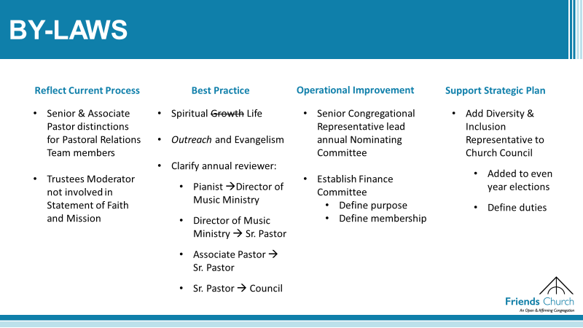

Kelly asked for any questions and comments. Request for screen sharing. Cecelia Hawkins moved and Andrew McNeely seconded the motion that the proposed bylaw changes be accepted. Motion carried.

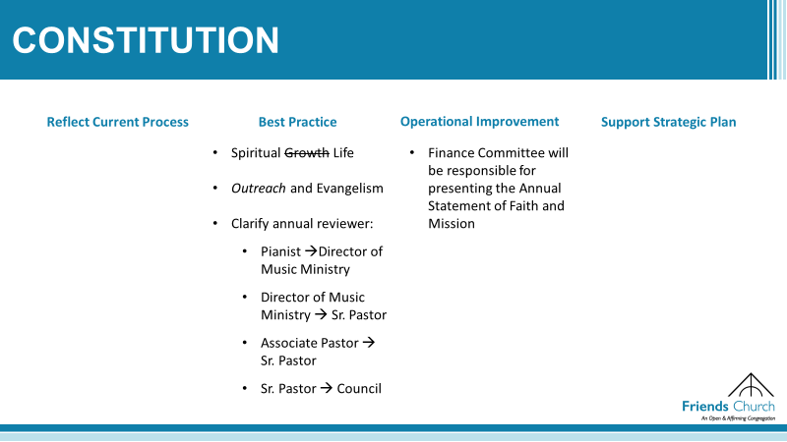
Nancy Bertsch moved and Katy Stewart seconded the motion that we accept proposed changes to the Constitution. Motion carried. (61 yes 2 abstain)
Kelly recognized and thanked our Outgoing Church Leaders:

Outgoing Church Leaders
Lauren Vaselli-Outreach | Sue Ambrus-Personnel
Jackie Womack- Congregational Rep | Jon Maxwell- Stewardship
Kevin Graham -Fellowship - | Theresa Walker-Treasurer
Andrew McNeely- Justice and Mission | Ella Maxwell-Youth Representative
Sally Manthi- Moderator of Trustees | Patrick Redmill- Senior Pastoral Relations
Pam & Cady Engler-Nuture | Emma Day-Genett Associate Pastoral Relations

Nominating Committee Report
Jackie Womack, Chair nominating committee and Congregational Representative introduced her nominating committee: Jill Fouch, Christine Gravelle, Wayne Hammon, Dan DeLeon (Ex Officio) Proposed slate of officers:

Proposed Church Leaders
Anna Transue -Outreach | Lauren Puente-Personnel
Brian Gilson -Congregational Rep | Carl Fahrenwald - Stewardship
Loretta Mendez -Treasurer- | Janet Richards Worship
Andrew McNeely- Justice and Mission | Collin Arledge- Senior Pastoral Relations
Moderator of Trustees—Bill Harper | Chris Abbott- Associate Pastoral Relations
Christina Ramirez- Nurture

Linda Coats moved and Cady Engler seconded the motion that the proposed slate of officers be accepted. Motion carried.

Kathy Langlotz, representing Senior Pastoral Relations committee, announced that Pastor Dan is due for 3 months of sabbatical during the years 2018-2021. He had planned to take a month of sabbatical after Easter, but due to COVID 19 he did not. The Senior Pastoral Relations committee will be working with Dan to find a workable time. Members of the congregation were very supportive of Dan taking time as needed.

Tom Vogel moved and Katy Steward seconded that the meeting be adjourned. Motion carried. Meeting was adjourned at 1:30.

Respectfully submitted,

Anne Wehrly, Council Secretary

